Solution Architecture Document
Migration of IBM BAW Process Application to Azure Logic Apps
Document Type: High-Level Solution Design (HLSD)
Version 0.1 — Draft
Date: 07 July 2026

Document Control

Revision History
Version | Date | Author | Description
0.1 | 07-Jul-2026 | Solution Architect | Initial draft for review

Distribution
- Enterprise Architecture / Integration CoE
- Application Owner / Business Sponsor
- BAW SME / Process Owner
- Azure Integration Team

Table of Contents

1. Executive Summary
This document describes the high-level target architecture and migration approach for converting an existing IBM Business Automation Workflow (BAW) process application to Azure Logic Apps. It defines how the three-tier BAW composition — Process, Step, and Reusable Service Flow — is re-platformed onto an equivalent three-tier Logic Apps composition, and sets out the cross-cutting design principles, component mapping, and phased migration roadmap needed to deliver a like-for-like, cloud-native replacement.
In scope: Architecture pattern for the process app, workflow decomposition strategy, component mapping from BAW to Azure, orchestration and error-handling approach, and a phased migration roadmap.
Out of scope: Detailed low-level design (LLD) for each individual step, connector-level configuration, and infrastructure-as-code implementation — these follow in subsequent LLD artifacts once this design is approved.

2. Purpose & Approach
The purpose of this document is to translate the existing IBM BAW process application structure into an equivalent, maintainable Azure Logic Apps solution while preserving the separation of concerns already established in BAW:
- A single orchestrating workflow represents the overall business process (equivalent to the BAW BPD / Process).
- One child workflow per process step encapsulates the logic for that step (equivalent to a BAW Step / Task / Subprocess).
- A shared set of reusable child workflows encapsulate external service integration and are invoked by one or more step workflows based on input data (equivalent to BAW Reusable Service Flows).
This three-tier decomposition is preserved deliberately: it keeps the migration conceptually close to the source system (easing traceability and testing), while mapping cleanly onto Logic Apps' native "Invoke Workflow" nesting capability.

3. Current State — IBM BAW Architecture
The existing BAW process application is composed of a main Business Process Diagram (BPD) that orchestrates a sequence of steps. Each step may be a human task, a system task, or a subprocess. Where a step needs to call an external system (REST/SOAP API, database, or backend system), it does so via a shared Reusable Service Flow, which may be invoked from multiple steps.
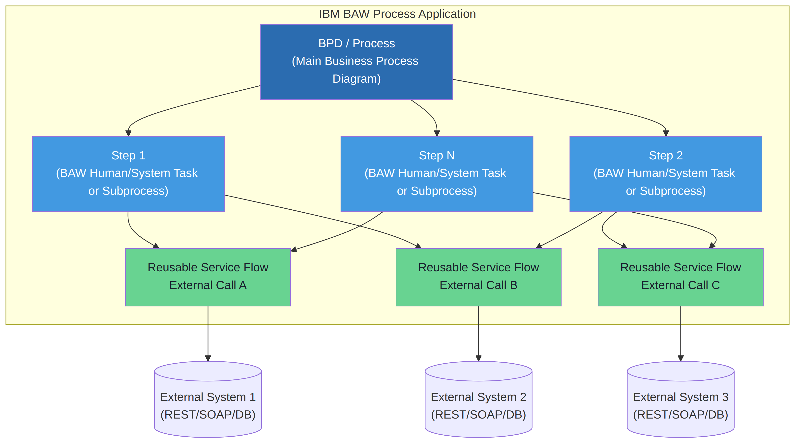
Figure 1 — Current state: IBM BAW process, step, and reusable service flow composition

Key characteristics
- Process (BPD) owns end-to-end sequencing, branching, and business state.
- Steps encapsulate a discrete unit of business logic and may be human or system tasks.
- Reusable Service Flows are shared, parameterised subprocesses used purely for external integration, invoked conditionally based on step input.
- BAW manages process instance state, task lists, and audit/history natively via its process engine.

4. Target State — Azure Logic Apps Architecture
The target architecture preserves the same three-tier decomposition using nested Logic Apps and the native Invoke Workflow (child workflow) action:
Tier | BAW Equivalent | Azure Logic Apps Equivalent | Responsibility
1 — Process | BPD (Process) | Main (Parent) Logic App | End-to-end orchestration: sequencing, branching, parallelism, overall status/state
2 — Step | Step / Task / Subprocess | Child Logic App per step | Step-specific business logic, data mapping, local decisioning
3 — Reused Service Call | Reusable Service Flow | Shared/Reused Child Logic App | External service integration (REST/SOAP/DB), invoked by one or more step workflows based on input

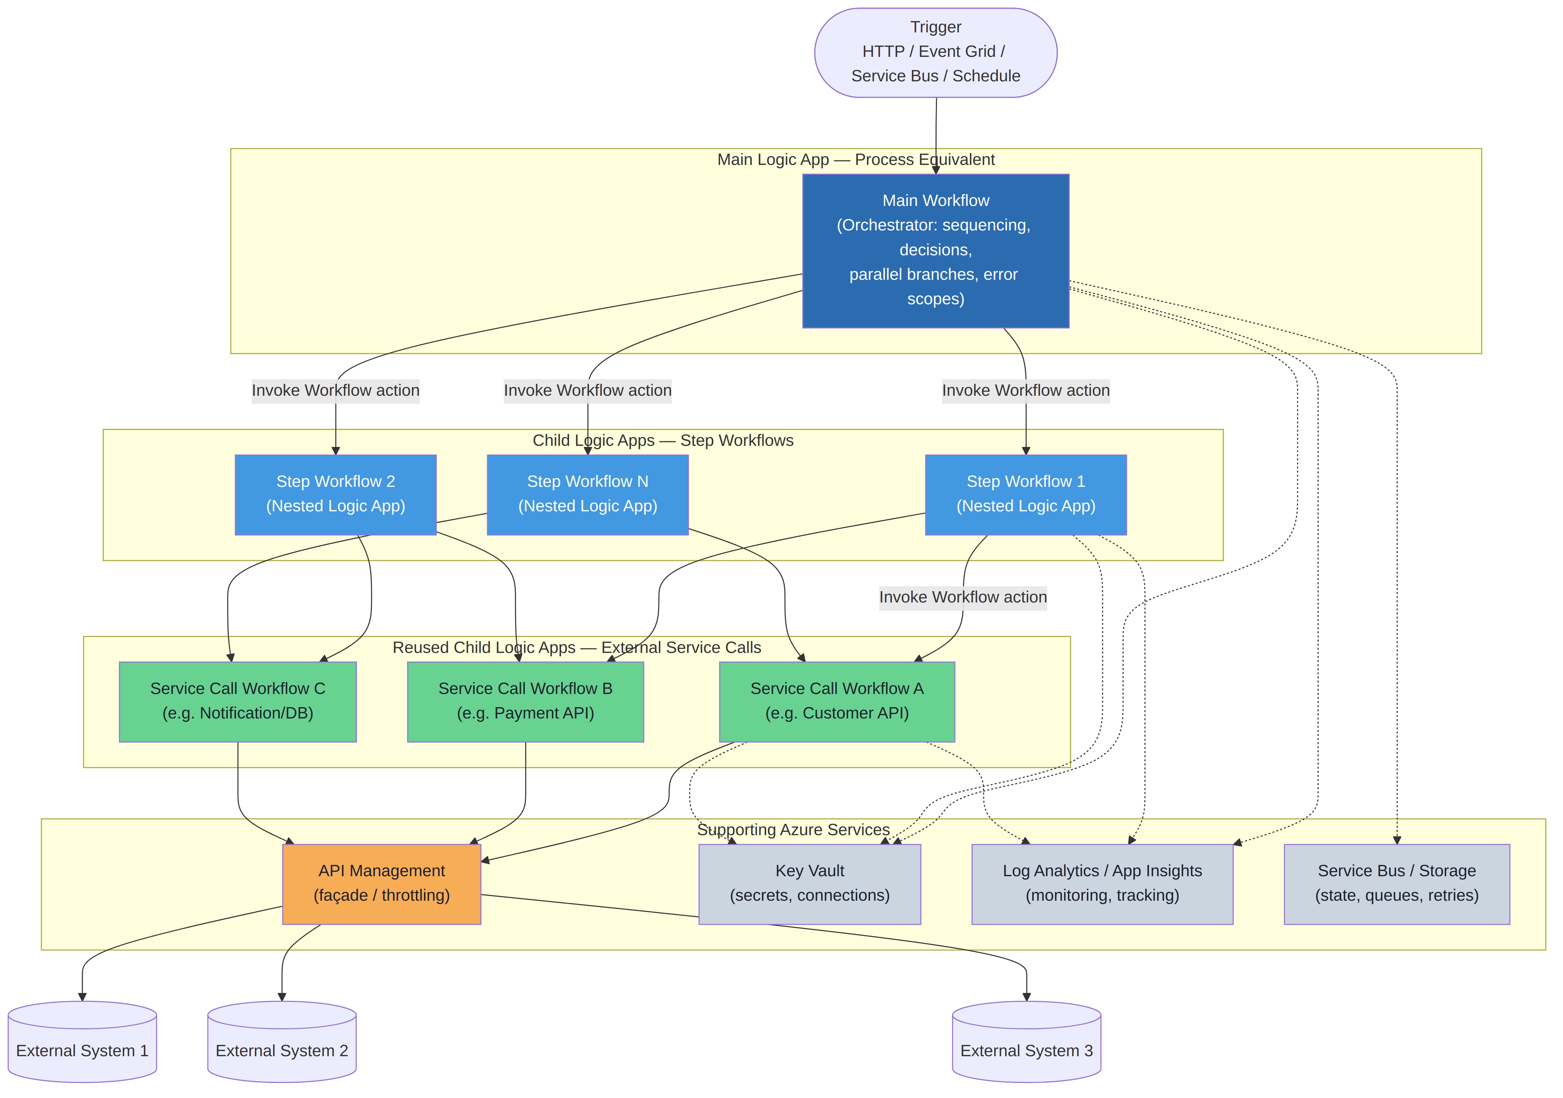
Figure 2 — Target state: Azure Logic Apps solution architecture

Design principles
- Main workflow calls step workflows using the "Invoke a Workflow (this Logic App)" / nested workflow action — never inlines step logic, to preserve modularity and independent deployability.
- Step workflows decide, based on their input payload, which reused child workflow(s) to invoke — mirroring the conditional invocation of Reusable Service Flows in BAW.
- Reused child workflows are single-purpose, stateless, and own only the external call contract (request mapping, call, response/fault mapping) — no business logic.
- All three tiers are built as Logic App Standard (single-tenant) workflows within one Logic App resource, or as separate Logic App resources per tier, depending on the scaling/deployment isolation decision (see Section 7).
- Shared connections, secrets, and schemas are centralised and referenced by all tiers rather than duplicated.

5. Orchestration & Call Flow
The sequence below illustrates a representative end-to-end invocation: the main process workflow triggers a step workflow, which in turn invokes a reused service-call workflow to reach an external system, with responses propagated back up the chain.
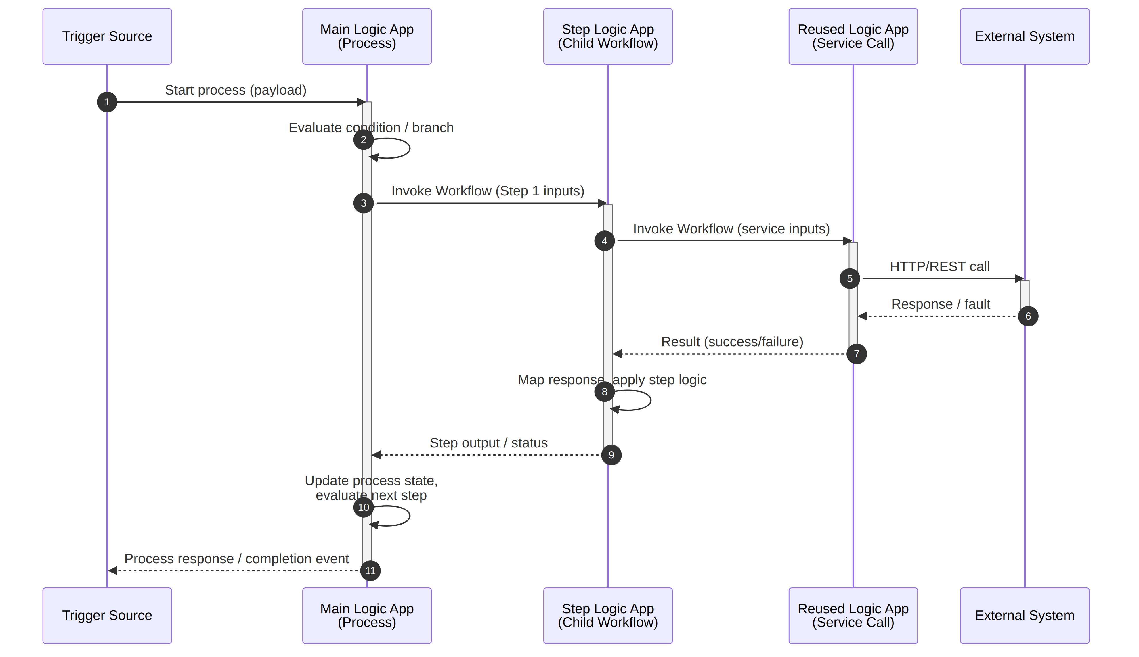
Figure 3 — Representative call sequence across the three workflow tiers
Each nested invocation is a synchronous "Invoke Workflow" call by default (matching BAW's synchronous subprocess call semantics). Where a step's external call is long-running, the reused child workflow can instead implement the async polling / webhook pattern internally, so this remains transparent to the calling step workflow.

6. Workflow Decomposition Strategy

6.1 Main (Process) Workflow
- Owns the trigger (HTTP, Event Grid, Service Bus, or Recurrence, matching the BAW start event).
- Holds the overall process variables / business state for the run.
- Sequences step workflow calls, including parallel branches, conditions, loops, and boundary/escalation handling equivalent to BAW timer and error intermediate events.
- Aggregates step outputs into the final process response or completion event.
- Wraps step invocations in Scope/Try-Catch-Finally patterns for process-level compensation.

6.2 Step (Child) Workflows
- One Logic App workflow per BAW step / task / subprocess, named consistently with the source BAW artifact for traceability (e.g. STP_ValidateOrder, STP_CalculatePricing).
- Receives a well-defined input contract from the main workflow and returns a well-defined output contract (JSON schema-validated).
- Contains the step's own business rules, data transformation, and conditional logic to decide which reused workflow(s) to call and in what order.
- Where the original BAW step was a Human Task (UI-driven), this is re-implemented outside pure Logic Apps — e.g. Power Automate/Power Apps task UI, or a custom task-management service — with the Logic App step workflow handling only the automated part of the step lifecycle. This is called out explicitly per step during detailed design.

6.3 Reused (Shared) Child Workflows
- One workflow per distinct external integration (per target system or per API), reused across any step workflow that needs it — matching BAW's Reusable Service Flow model.
- Owns only: request mapping from a generic input contract, the outbound call (HTTP, SOAP via XML transform, or DB connector), response/fault mapping, and standard retry policy.
- Never contains business logic — kept generic so it can be safely reused and independently versioned.
- Exposes a stable input/output contract so step workflows can be added or changed without modifying the reused workflow.

7. Cross-Cutting Design Considerations

7.1 Hosting Model
Logic Apps Standard (single-tenant, App Service Plan or Workflow Standard hosting) is recommended over Consumption, to support: multiple workflows per app (matching the nested tier model efficiently), VNet integration for private connectivity to backend systems, and predictable performance/cost at scale.

7.2 State, Correlation & Long-Running Processes
- Logic Apps run history provides per-run state equivalent to a BAW process instance; a business correlation ID (from BAW's process instance ID or a new GUID) is passed through all tiers and logged at every hop.
- For processes with human tasks or long wait states, use Service Bus / Storage Queues plus webhook callback or the built-in "Wait for callback" pattern to avoid long-running synchronous chains.

7.3 Error Handling & Resilience
- Reused child workflows implement transient-fault retry policies (exponential backoff) on the external call action.
- Step workflows catch and classify errors from reused workflows (business fault vs technical fault) and return a structured error contract to the main workflow.
- Main workflow implements a top-level Try/Catch/Finally scope with compensation/notification logic, equivalent to BAW's exception handling and error intermediate events.

7.4 Security
- Managed Identity for all Azure-to-Azure and Azure-to-API Management calls; no credentials embedded in workflow definitions.
- Azure Key Vault for all external system credentials/certificates/connection strings, referenced via Key Vault-backed connection parameters.
- API Management as a façade in front of external/backend systems where available, to centralise throttling, IP allow-listing, and contract versioning.

7.5 Monitoring, Logging & Audit
- Application Insights / Log Analytics integration on every Logic App for run history, tracked properties, and custom business logging equivalent to BAW's Process/Task audit trail.
- Business correlation ID, step name, and reused-workflow name emitted as tracked properties on every run for end-to-end traceability across all three tiers.
- Alerting on failed runs, retries exhausted, and SLA breaches, replacing BAW's Performance Data Warehouse / dashboards.

7.6 Performance & Scaling
- Reused workflows scale independently as they carry the highest call volume (invoked by multiple steps); consider separate Logic App resources for high-volume integrations.
- Concurrency controls (trigger concurrency, chunking) applied on the main workflow to match BAW's process instance throughput limits.

8. Data & Business Rules Migration
- BAW Business Object (BO) definitions are converted to JSON Schemas, used to validate inputs/outputs at each workflow tier boundary.
- Coach-view/UI-bound data mapping is separated from process data mapping; only the latter carries over directly into Logic Apps parameters and Data Operations actions.
- Business rules encapsulated in BAW Decision Services / Business Rules are re-implemented as: Logic Apps Condition/Switch actions for simple rules, or Azure Function / Rules Engine call from within the relevant step workflow for complex decision tables.
- Reference/lookup data used by BAW rules is migrated to Azure SQL, Cosmos DB, or Blob-based lookups depending on volume and update frequency.

9. Migration Approach & Roadmap
A phased, bottom-up build sequence is recommended: build and stabilise the reused integration workflows first (since they are shared dependencies), then step workflows, then the orchestrating main workflow — followed by parallel-run validation against the existing BAW application before cutover.
Figure 4 — Indicative phased migration roadmap
Phase | Key Activities | Key Output
1. Discovery & Assessment | Inventory all BPDs, steps, subprocesses, reusable service flows, BOs, and external integrations in the BAW app | Migration inventory & complexity assessment
2. Target Design | Define Logic App hierarchy, hosting model, connector strategy, error/state model | Approved HLSD (this document) + LLD templates
3. Foundation Build | Build/test reused service-call workflows, shared schemas, and connections | Reusable integration workflow library
4. Step Workflow Build | Build/test step workflows using the reused library | Tested step workflows
5. Main Process Build | Build/test the orchestrating main workflow | End-to-end process workflow
6. Test & Parallel Run | Functional, integration, performance, and parity testing against BAW | Sign-off / go-live readiness
7. Cutover & Hypercare | Production deployment, monitoring, decommission BAW app | Live Azure solution

10. Assumptions, Risks & Dependencies

10.1 Assumptions
- All BAW human tasks / Coach Views are either replaced by an alternative task UI mechanism or out of scope for this Logic Apps migration phase.
- Target Azure landing zone (networking, Key Vault, API Management, monitoring) is available or being provisioned in parallel.
- Source BAW process, step, and reusable service flow inventory can be fully extracted for mapping.

10.2 Risks
- Complex BAW Business Rules/Decision tables may not map cleanly to native Logic Apps expressions and may require an external rules engine, adding effort.
- Long-running/human-task-heavy processes may require additional state-management components not present in a pure Logic Apps design.
- Parity testing against a live BAW system may be constrained if the BAW environment is being decommissioned in parallel.

10.3 Dependencies
- Availability of API/service contracts for all external systems currently called via BAW Reusable Service Flows.
- Azure landing zone readiness (networking, identity, Key Vault, API Management, monitoring).
- Business sign-off on any re-platformed human-task/UI approach.

11. Appendix — Glossary
Term | Definition
BAW | IBM Business Automation Workflow — BPM/case management platform
BPD | Business Process Diagram — the main process definition in BAW
Reusable Service Flow | A shared BAW subprocess used purely for external system integration
Logic App (Standard) | Azure single-tenant workflow hosting model supporting multiple nested workflows per app
Invoke Workflow action | Native Logic Apps action to call another (child) workflow synchronously
APIM | Azure API Management — API façade/gateway service
HLSD | High-Level Solution Design

